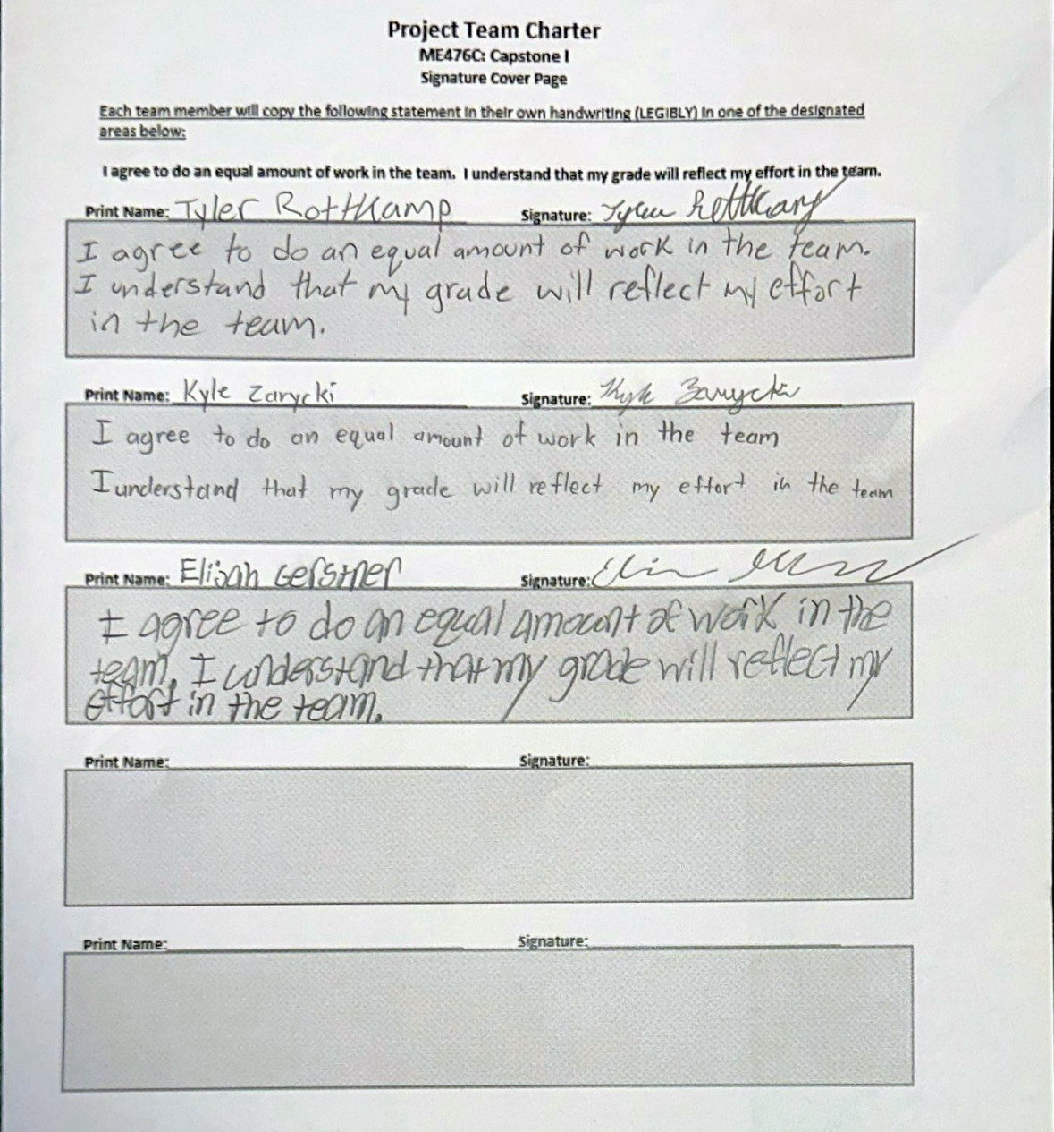

Team Purpose
The purpose of this team's formation is to collaborate on a senior capstone project. This capstone project is sponsored by Gore LLC, and the expectation is that the team could use their skills to create a working autonomous robot that can pick up pinecones. Secondary stakeholders include elderly people as well as Flagstaff businesses that would benefit from using a final version of this robot.
Team Goals
The goal of the project is to design and build an autonomous robot that can remotely navigate terrain in Flagstaff and pick up pinecones within a specified area. To meet this goal the use of sensors and control systems will be needed. At the same time the team will maintain regular check-ins with the sponsor at W.L. Gore to ensure that they are following the company's goals and guidelines for the project.
The process goals follow a timeline of iterations. In the first iteration there will be an autonomous platform that will use a simple collision avoidance system to pick up objects. Subsequent iterations will refine this process eventually leading to a robot that will follow a mapped-out area to quickly and effectively pick up pinecones, while filtering out other debris.
For quality and performance goals, the robot will be designed for outdoor durability rather than aesthetics. The team will focus on creating and refining working prototypes based on the feedback from Gore, so the project meets design criteria and earns an A in the course.

Team Member Personalities/Roles/Responsibilities
Kyle Zarycki - Project Lead / Drivetrain Design
This team member is dedicated to working with and leading the team. They consistently contribute to group work and discussion while also taking initiative on tasks.
Tyler - Budget liaison / Body system
This team member is hard working and works well in a collaborative setting. They are consistently helpful and demonstrate independence as well as patience.
Eli – Administration / Collection System
This team member is organized and creative. They are skilled at design innovation and system management solutions, as well as helping the team to organize objectives and paperwork.
Siyu Yu - Computer Aided Engineering / Collection System
This team member is quiet but highly focused and dedicated to polishing the details of the project. They will lead the effort to model our project in a 3D design program, including parts producible by additive manufacturing.

Ground Rules
The team will meet regularly to discuss progress on the project. They will dedicate class time on Wednesday to team discussions, progress updates and other collaborative work. Outside of class time, the team members are available to meet Monday through Thursday after 2 PM as well as Friday between 12:30-5pm. Members are expected to attend all scheduled meetings unless they inform the group they cannot ahead of time.
During meetings, an agenda will be prepared beforehand to keep discussions focused and organized. For design-related discussions, design reviews will be held so team members can all provide input and suggest changes. If a decision needs to be made, a vote will be taken where a 60% majority is required. If dissenting views arise, every team member will share their opinion so all voices can be heard; then a re-vote will be initiated.
To maintain a structure throughout the course of the project, the team will use an action tracker where team members will assign tasks to themselves as well as due dates. This will help inform other team members what tasks each team member is working on as well as what tasks they need assistance with.
Each team member is expected to contribute a minimum of nine hours per week towards the project. If a team member feels that others are not being accountable for their work, a three-step process will be followed. First address the issue one-on-one with the members involved. Then escalate to a team wide discussion. If an accountability error still exists, the team will seek guidance from the professor.

Potential Barriers and Coping Strategies
- Participation and disagreements are the main issues that could arise. Solution procedures are listed in the previous section.
- If personal issues arise outside of school, the individual will inform the team and strategically divide work out to other members of the team.
- One problem with team dynamics is inconsistent roles.
  - There will be a lot of collaboration, so if multiple people are working under the same role, the person originally assigned that role will be responsible for tracking and assigning work.
Project Mentors
- In project
  - W.L. Gore Contacts
  - Professor David Willy
- Out of Project
  - Professor Dante
  - Professor Reza
  - Professor Solis
  - Reach out to a mechatronics or coding industry engineer if needed

